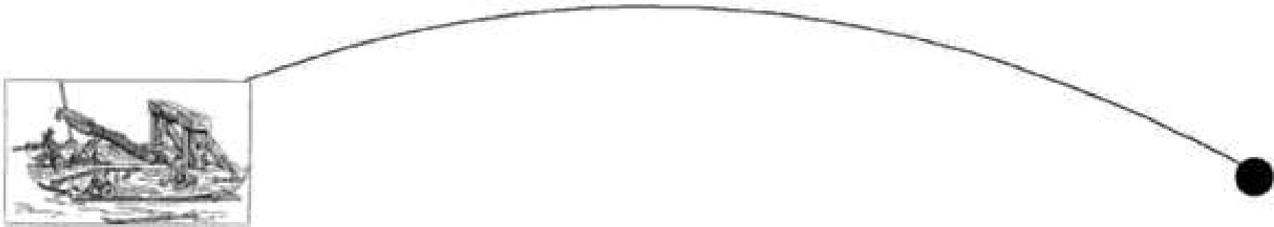

**Name- Pulkit Arora Roll no. 102103267 Group- 2CO10**



**DEPARTMENT**

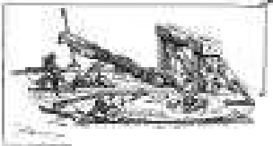

*--=--......,,, .-1*

OF

**ELECTRONICS AND COMMUNICATION .ENGINEERING**



OF E.NGf''JE.ER.IlvG &. TE.Cf NOi..OGY

f:med to b Un1\'<':Ts.1tyJ

# Handout/Assignment-1

for

# Engineering Design Project-I (UTA013)

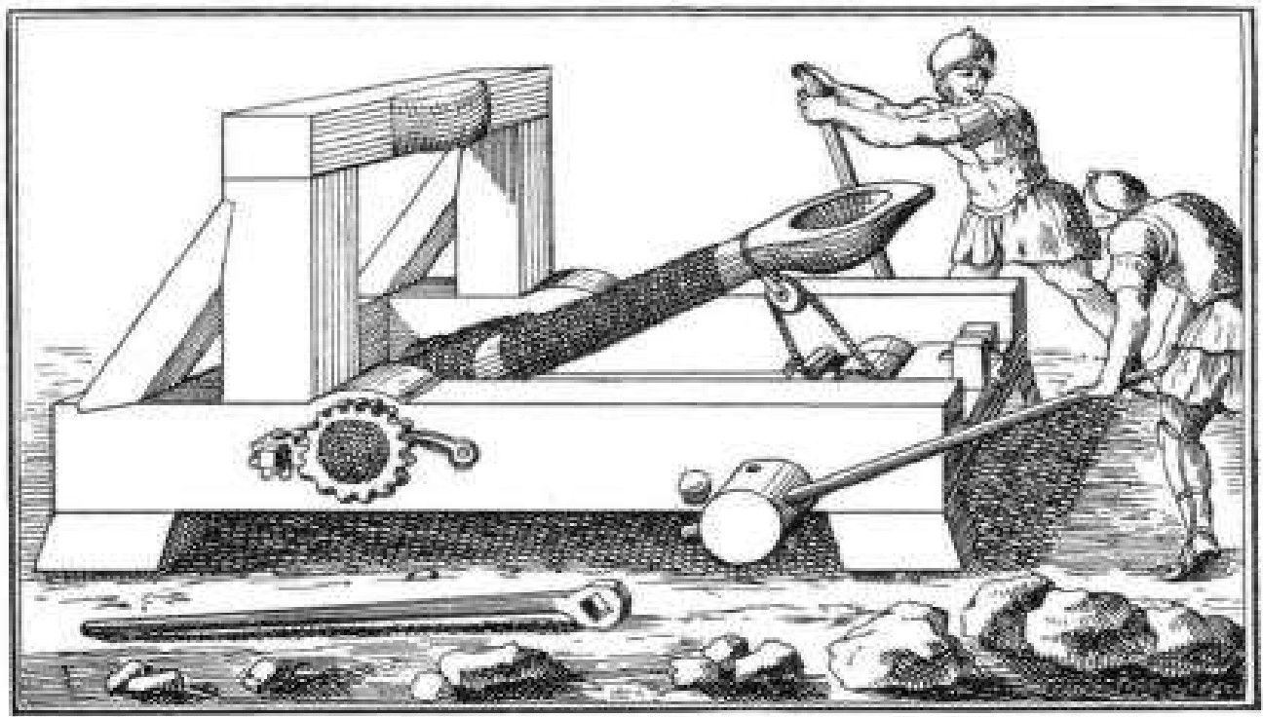

INSTRUCTOR INCHARGE

**Name – Pulkit Arora Roll no.- 102103267 Group- 2CO10**

**Exercise 1 (C) – Tinkercad**

Tinkercad is a free, online collection of software tools for 3D design, electronics, and coding

**Software Required**

* Tinkercad Software tool (<https://www.tinkercad.com/>)

**Getting Started:**

1. Visit <https://www.tinkercad.com/>
2. Sign in through your google account (Thapar Email ID only)
3. On the Dashboard, select **Circuits** from the drop box and click on **Create new Circuit**



**Name- Pulkit Arora Roll no.- 102013267 Group- 2CO10**

**Assignment Tasks:**

***Note: Each student must attach separate sheets for submitting the below mentioned Assignment Task A-C.***

1. Using Tinkercad, hook up 5 LEDs to pins 2 through 6 (with resistors). Modify the code to turn on each one in order and then extinguish them in order.

*(HINT: hook them up one additional LED at a time and make sure the new one works before you add the next one.)*

**Code:**

**Name- Pulkit Arora Roll no.- 102013267 Group-2C010**

**Tinkercad Screenshot-**

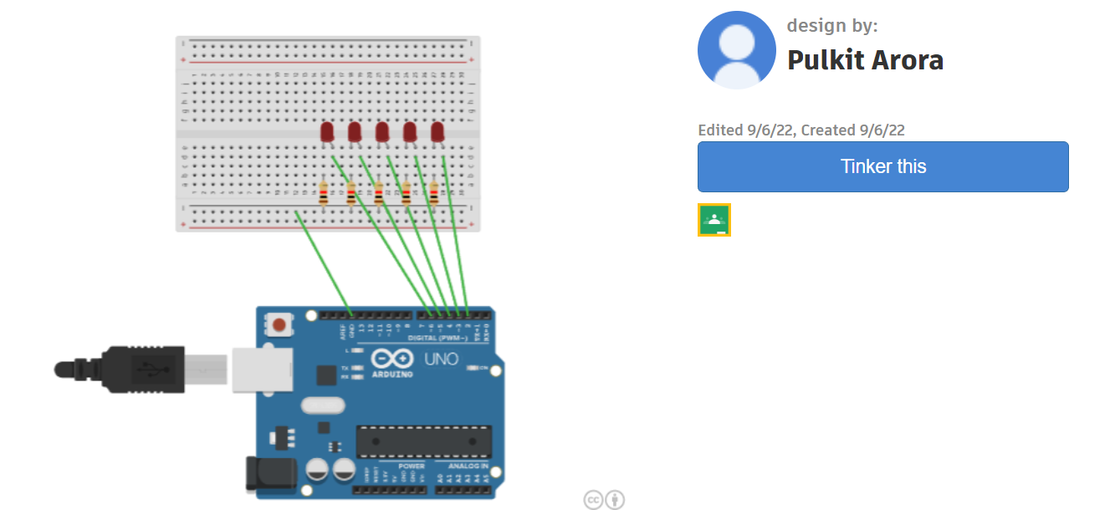

**Schematic:**

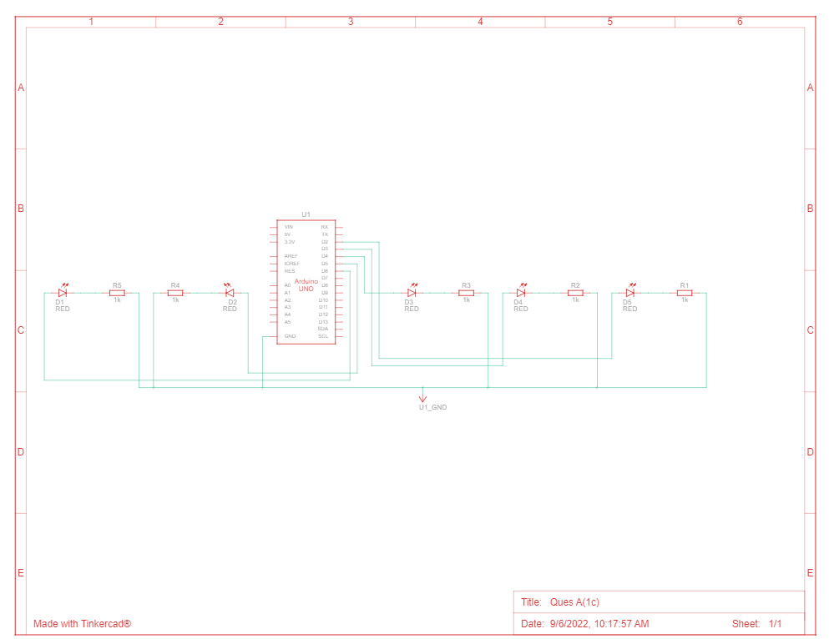

**Name- Pulkit Arora Roll No. 102013267 Group- 2CO10**

1. With the help of Tinkercad, use push buttons to simulate the behaviour of listed logic gates (Without using ICs of logic gates)
   1. Logic gates: AND, NAND, XOR for students with odd numbered Roll Number.

**Hint:**



**Name- Pulkit Arora Roll no.- 102103267 Group- 2CO10**

**Tinkercad Screenshot:**

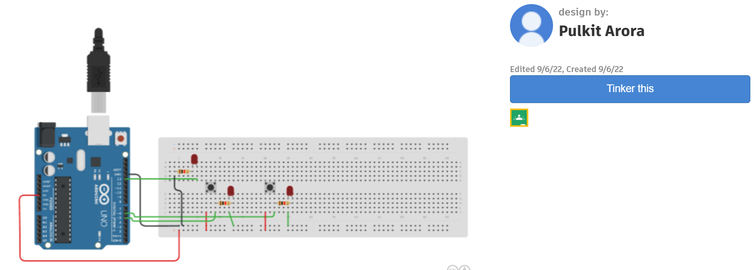

**Schematic:**

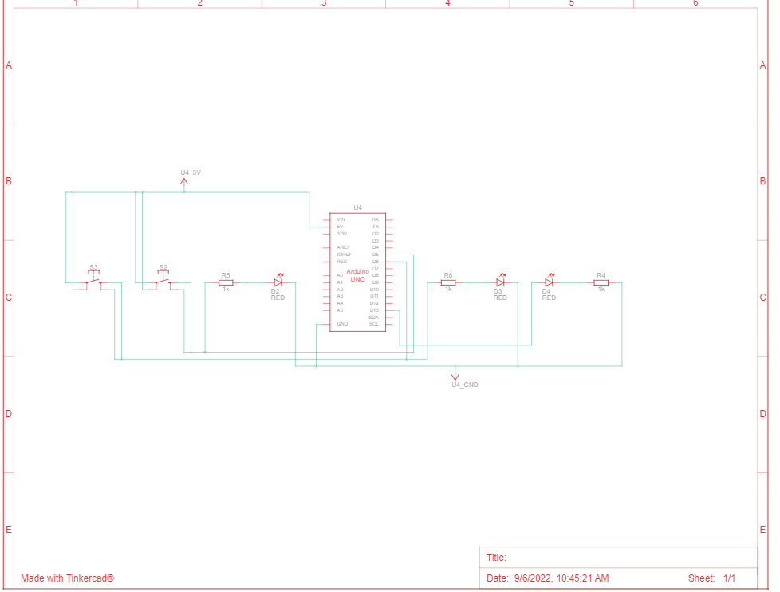

**Name- Pulkit Arora Roll no.- 102103267 Group-2C010**

**CODE:**

1. **AND Gate**
2. **NAND Gate**

**Name- Pulkit Arora Roll no. 102103267 Group-2CO10**

1. **XOR Gate**